Robust Object Detection System Under Adverse Weather Conditions



By

Abdul Qahir Jalali
2021-UMDB-001017

Raja Sharyar Muneer
2021-UMDB-001041

Supervisor

Dr. Maryam Bibi
Associate Professor

DEPARTMENT OF COMPUTER SCIENCES & INFORMATION TECHNOLOGY
FACULTY OF SCIENCE
UNIVERSITY AZAD JAMMU & KASHMIR
MUZAFFARABAD

Session: 2021-2025

APPROVAL CERTIFICATE



It is certified that the project work presented in this report entitled “Robust Object Detection System Under Adverse Weather Conditions,” submitted by Abdul Qahir Jalali (Roll No. 53) and Raja Sharyar Muneer (Roll No. 83) of Session 2021–25 under the supervision of Dr. Maryam Bibi, is considered adequate in scope and quality for the Bachelor of Science in Computer Science, subject to approval by the competent university authorities.

_________________ __________________

(Supervisor) (External Examiner)
Dr. Maryam Bibi
Associate Professor
Department of CS & IT,
University of Azad Jammu & Kashmir
Muzaffarabad

_________________

(Chairman)
Dr. Sajjad Ahmed Nadeem
Department of CS & IT
University of Azad Jammu & Kashmir
Muzaffarabad


ABSTRACT

Robust Object Detection System Under Adverse Weather Conditions is a web-based prototype for detecting selected people and vehicles in uploaded images and videos. It combines a fixed OpenCV enhancement sequence with pretrained YOLOv8 inference and a browser interface. The image route returns the predicted class, confidence score, bounding-box coordinates, person and vehicle counts, and an annotated image. The video route processes uploaded frames and returns an annotated MP4 file.
The backend uses FastAPI and is divided into routes, configuration, response schemas, image utilities, and enhancement and detection services. Enhancement applies an intensity lookup table, bilateral filtering, CLAHE on the luminance channel, and mild sharpening. For video, wide frames are resized to a maximum width of 640 pixels and inference is performed on every fifth frame; the most recent annotation is reused between sampled frames. These are implementation settings rather than results of a parameter-optimization study.
The detector loads local yolov8m.pt weights, uses a confidence threshold of 0.15, and filters predictions to the COCO person, car, motorcycle, bus, and truck classes. The code demonstrates pretrained inference; it does not contain a project-specific training pipeline, labeled weather dataset, benchmark results, or object tracking. The project therefore provides an integrated prototype while leaving detection accuracy and the effect of enhancement to a controlled evaluation.
Keywords: object detection, YOLOv8, adverse visibility, OpenCV, FastAPI, image enhancement, video processing, prototype validation protocol.

UNdertaking

We certify that this report describes our project work. Technical sources used in the background and implementation discussion are acknowledged in the references. Statements about implemented behavior are based on the project files available for review; performance conclusions are not claimed without measured evaluation.

________________ __________________
(Student’s Signature) (Student’s Signature)
Abdul Qahir Jalali Raja Sharyar Muneer
2021-UMDB-001017 2021-UMDB-001041

Acknowledgements

All praise is due to Allah, the Lord of all the worlds. We are grateful for the strength and opportunity to complete this project and its documentation.
We extend our sincere gratitude to our supervisor, Dr. Maryam Bibi, for her guidance, encouragement, and support throughout our academic work. We also thank the faculty members whose teaching helped us develop the knowledge needed to plan and implement this project.
We are thankful to our parents, families, and friends for their patience and support during the project. Their encouragement helped us complete the work and prepare this report.

Table of Contents

UNdertaking v
Acknowledgements vi
Table of Contents vii
List of figures x
Chapter 1 1
1.1 Problem Statement and Motivation 1
1.1.1 Motivation for the Solution 2
1.2 Scope 2
1.2.1 Inclusions and Exclusions 2
1.3 Aims and Objectives 3
1.4 Limitations 3
1.5 Intended Audience and Target Users 4
Chapter 2 5
2.1 Object Detection and Computer Vision 5
2.1.1 Overview of Object Detection 5
2.1.2 Evolution of Object Detection Models 6
2.1.3 Challenges in Adverse Visibility 6
2.2 Deep Learning for Vision 6
2.2.1 Feature Extraction and Representation in Images 7
2.2.2 Deep Learning Architectures for Image Analysis 7
2.2.3 Challenges in ML-Based Object Detection 8
2.3 Existing Solutions and Research Gaps 8
2.3.1 Existing Object Detection Systems 8
2.3.2 Limitations of Current Approaches 9
2.4 Technologies Overview 9
2.4.1 YOLOv8 Object Detection 10
2.4.2 FastAPI Framework 10
2.4.3 OpenCV 10
2.4.4 Supporting Libraries and Tools 11
Chapter 3 12
3.1 Architecture Overview 12
3.1.1 High-Level Design 12
3.1.2 Architectural Layers 13
3.2 Component Details 13
3.2.1 FastAPI Server 13
3.2.2 OpenCV Integration 14
3.2.3 Image Preprocessing and Enhancement 14
3.2.4 YOLOv8 Detection Model 14
3.2.5 User Interface 15
3.3 Media Processing and HTTP Communication 15
3.3.1 Image and Video Processing Workflow 15
3.3.2 Data Exchange Patterns 15
3.4 Data Flow 16
3.4.1 Image and Video Data Flow 16
3.4.2 Detection Result Flow 18
3.4.3 Image Request Sequence 18
3.4.4 Activity Diagram 20
3.4.5 System Overview Diagram 21
3.4.6 System Architecture Diagram 22
3.4.7 Use Case Diagram 23
Chapter 4 24
4.1 Pretrained Detection Model 24
4.1.1 Model Overview 24
4.1.2 Weights and Class Selection 25
4.1.3 Inference and Evaluation Plan 25
4.1.4 Confidence and Runtime Settings 27
4.2 Image Preprocessing and Enhancement 27
4.2.1 OpenCV Enhancement Pipeline 27
4.2.2 Input and Output Image Handling 27
4.3 FastAPI Integration and Model Serving 28
4.3.1 Backend Implementation 28
4.3.2 Frontend Implementation 28
4.4 System Implementation 28
4.4.1 Backend Development 29
4.4.2 Frontend Development 29
4.4.3 Verification and Error Handling 29
4.5 Local Deployment and Verification 30
4.5.1 Deployment Environment 30
4.5.2 System Verification Plan 30
Chapter 5 31
5.1 Home Page Overview 31
5.2 Detection Result Interface 32
5.3 Navigation and Layout 33
5.4 Interface Design Principles 34
5.5 Accessing the System 34
5.6 Uploading Image and Video Files 34
5.7 Interpreting Detection Results 35
Chapter 6 37
6.1 Verification and Evaluation Status 37
6.1.1 Detection Performance Evaluation Plan 37
6.1.2 Enhancement Evaluation 38
6.1.3 Confidence Threshold Evaluation 38
6.1.4 Processing Time Evaluation 39
6.1.5 Web Application Verification 39
6.2 Evaluation Protocol 39
6.2.1 Representative Image and Video Sources 39
6.3 Findings from the Implemented Prototype 40
6.4 Limitations and Challenges 40
6.4.1 Technical Limitations 40
6.4.2 Operational Limitations 40
6.5 Future Implications 41
Chapter 7 42
7.1 Conclusion 42
7.2 Contributions 42
7.3 Lessons Learned 43
7.4 Recommendations 44
7.5 Future Work 44
References 46
Abbreviations 47

List of figures

Figure 3.1: Image and Video Data Flow 17
Figure 3.2: Image Request Sequence 19
Figure 3.3: Media Processing Activity 20
Figure 3.4: System Overview 21
Figure 3.5: Application Architecture 22
Figure 3.6: User Use Cases 23
Figure 4.1: Proposed Evaluation Protocol 26
Figure 5.1: Browser Interface 32
Figure 5.2: Image Result Interface 33
Figure 5.3: Video Result Interface 36
Figure 6.1: Validation and Error Paths 38

Chapter 1

Introduction

This report documents the design and implementation of a web-based object detection prototype for images and videos in challenging visibility conditions. It describes the application structure, enhancement sequence, pretrained detector, request and response formats, browser workflow, and limits visible in the delivered source. The system combines OpenCV preprocessing with YOLOv8 inference behind a local FastAPI application.
The project proposal identifies low light, rain, and fog as motivating conditions. The implementation supplies general image operations, but no labeled weather dataset or benchmark results. This report therefore distinguishes implemented functions from future evaluation instead of presenting an unverified accuracy claim.
Chapter 1 defines the motivation and limits. Chapter 2 provides the computer-vision background. Chapter 3 follows media through the system architecture. Chapter 4 records the implementation and settings. Chapter 5 explains the interface. Chapter 6 separates code verification from performance evaluation. Chapter 7 concludes with recommendations and future work. Together these chapters describe a prototype and make clear which results require further evidence.

1.1 Problem Statement and Motivation
Object detectors depend on visual cues such as edges, texture, shape, and contrast. Low illumination, glare, fog, rain, blur, and compression can weaken or obscure these cues. A detector may miss an object, predict an incorrect class, or place a bounding box inaccurately. This project addresses the problem by applying image processing before pretrained object detection and exposing the workflow through a browser. It is a prototype for uploaded media, not a safety-certified monitoring system or an autonomous vehicle controller. The specific engineering problem is to connect input validation, image enhancement, detector inference, and clear result delivery in one reproducible application.

1.1.1 Motivation for the Solution
Computer vision is used in road monitoring, surveillance, and visual inspection, yet a model that works well on clear images may not behave equally on degraded inputs. A local upload-and-analysis tool lets a user examine images and videos without preparing a command-line inference pipeline. The enhancement stage makes the processing sequence explicit, so later experiments can compare it with inference on unmodified media. Whether the enhancement improves detection must be measured with labeled examples; visual changes alone do not establish better recognition, and no filter can reliably reconstruct details missing from the source. The web interface lowers the effort required to submit media and inspect an annotation. Separating services makes it possible to test enhancement and model inference independently later.

1.2 Scope
The application serves a static browser page and provides API routes under /api/v1. The image endpoint receives an uploaded image, decodes and enhances it, runs YOLO inference, then returns person and vehicle counts, individual labels, confidence scores, bounding-box coordinates, and an annotated image encoded in base64. The video endpoint accepts an uploaded video, processes frames with OpenCV, and returns an annotated MP4. The model is loaded from local weights and runs on the host machine. The API is designed for local use with one uploaded file per request.

1.2.1 Inclusions and Exclusions
The project includes FastAPI request handling, static HTML, CSS and JavaScript, image and video uploads, OpenCV decoding and enhancement, YOLO inference, response formatting, and annotations. Its inference filter selects the COCO person class and four vehicle classes: car, motorcycle, bus, and truck. The repository does not include model training, a curated labeled dataset, weather-specific weights, recorded benchmark results, persistent user accounts, a database, or object identity tracking.
Video is submitted as a file; the application does not stream from a camera. A single image response contains structured detections and a rendered image. A video response is an MP4 artifact without a parallel table of frame-level predictions.

1.3 Aims and Objectives
The aim is to integrate image enhancement and pretrained object detection in a usable local web application.
Objectives are to separate API routes, schemas, configuration, utilities, and model services; accept image and video files; apply a consistent processing sequence; identify selected people and vehicle categories; return interpretable detections for images; and generate annotated video output.
A further objective is to document the configuration needed to reproduce inference, including the weight file, confidence threshold, allowed classes, maximum video-frame width, and sampling interval.
The implementation should remain understandable enough for later testing and extension.

1.4 Limitations
The model uses general pretrained weights and may not represent local roads or adverse weather.
The code includes no fine-tuning process, labeled validation split, or measured accuracy results. Enhancement parameters are fixed and can help some scenes while degrading others.
The image route counts detections in one image, not unique identities over time.
Video inference runs on every fifth frame and reuses the latest annotated frame between detections, so boxes can be stale for moving objects.
The application has no explicit upload-size cap, authentication, persistent storage, or production deployment controls.
Runtime also depends on the host processor, model loading, input size, codec availability, and installed package versions. The video route stores temporary media on disk and depends on OpenCV's ability to read and write the selected format. Its error handling should be reviewed for partial files and cleanup.

1.5 Intended Audience and Target Users
This report is intended for project evaluators, computer-science students, developers extending the code, and users who need to inspect uploaded images or videos. It explains what the prototype does and what remains unverified. A displayed box is a model prediction, not a verified fact. A researcher can use the described pipeline as a starting point for a controlled comparison, provided a labeled test set is assembled and the model, hardware, threshold, and evaluation settings are recorded. High-impact decisions should not rely on this prototype alone.

Chapter 2

Background and Technologies

This chapter introduces the computer-vision concepts and software technologies relevant to the project. The system joins a pretrained detector, image enhancement operations, an HTTP application, and a browser interface. The technical challenge is to connect these components while making input, output, and assumptions explicit.
General background is separated from project-specific implementation: research on detectors and enhancement explains the field, while statements about the implemented application are based on the repository. Performance claims belong to a controlled evaluation and are not inferred from the presence of a working interface. The discussion covers detector terminology, learned visual features, adverse visibility, enhancement, and the selected software stack.

2.1 Object Detection and Computer Vision
Computer vision converts image pixels into descriptions of a scene. Image classification assigns one or more labels to an image; localization estimates object position; detection predicts both category and position for multiple objects.

2.1.1 Overview of Object Detection
A bounding box is generally expressed by two coordinate corners, here named x1, y1, x2, and y2. The selected class describes the model's category prediction, while confidence is the model score associated with that prediction. A threshold discards candidates below a configured value; the framework may also apply its own overlap filtering.
In this application Ultralytics returns a result object containing boxes, scores, class IDs, and class names. The route converts those values to Pydantic models and uses the result's plotting function to produce the annotated image. Coordinates are tied to the image array passed into inference and are not ground-truth measurements. Detection and classification answer different questions.

2.1.2 Evolution of Object Detection Models
Early detection systems combined manually designed image features with classifiers. Deep convolutional networks learned more effective representations from examples and enabled region-proposal methods such as R-CNN and its successors. These two-stage systems first identify candidate regions and then classify them. Single-stage methods such as SSD and YOLO predict locations and categories in a more direct pass, often reducing inference time.
New model generations adjust their architectures, data pipelines, and training procedures, so family names alone do not determine a particular model's quality. This project uses the Ultralytics YOLO interface and a local yolov8m.pt file. The choice reflects an existing pretrained implementation that can be integrated into a small Python service. It does not establish superiority over Faster R-CNN, SSD, or other YOLO variants.

2.1.3 Challenges in Adverse Visibility
Low illumination reduces signal and may increase the relative effect of sensor noise. Bright headlights or reflections can saturate pixels and hide texture. Fog and rain scatter or obscure light, reducing contrast between objects and backgrounds; motion blur removes edge detail, and compression adds artifacts.
Occlusion may hide part of an object even in clear weather. The effect varies with camera, distance, object size, exposure, weather intensity, and image processing in the capture device. One weather label therefore does not describe a uniform detection problem. Image enhancement can alter local or global pixel values, smooth some noise, and sharpen some boundaries. It cannot reliably reconstruct an object hidden by an opaque obstruction or clipped by saturation.

2.2 Deep Learning for Vision

Deep-learning vision systems learn layered image representations from training data. Shallow feature maps can encode local intensity changes and edges, while later layers combine patterns over larger regions. Detection heads use those features to predict object categories and box positions at one or more scales. The project does not define these layers itself; Ultralytics loads pretrained weights and performs inference.
Application code controls the image supplied to the model, the class filter, the confidence threshold, and the handling of results. The pretrained model's learned behavior is inherited from its training process and cannot be attributed to this project without additional evidence.

2.2.1 Feature Extraction and Representation in Images
An image is stored as a grid of color values, commonly in three channels. Local edges and color transitions can distinguish a vehicle from a road or a person from the background. Larger shapes and context help resolve ambiguous patches. Small or distant objects occupy few pixels, so resizing and blur can remove useful detail.
In the image route, OpenCV decodes to a color array and passes the enhanced array into YOLO. In the video route, frames wider than 640 pixels are resized proportionally before enhancement and inference. That limit lowers per-frame work but also changes the amount of visual detail available to the detector. The enhancer converts the smoothed BGR frame to LAB, applies CLAHE to the luminance channel, then converts the image back to BGR before sharpening. This separates brightness processing from two color-opponent channels.

2.2.2 Deep Learning Architectures for Image Analysis
A one-stage detector maps image features to candidate boxes and class scores in a single inference pipeline. The Ultralytics API hides the detailed model internals from the web route and supplies a result object.
In code, the service calls the model with a confidence threshold and selected class IDs, then returns the first result. This abstraction keeps route logic focused on validation and response conversion, while the detector service handles model loading and prediction. The repository contains pretrained YOLOv8 weights rather than a training project. It has no dataset manifest, annotation files, loss calculation, optimizer, epoch loop, or training configuration.
The medium weights path is the default in configuration. Therefore the report describes transfer of an existing model into an application, not a new neural architecture or fine-tuned checkpoint. Any future training effort would require separate data provenance, class definitions, train/validation/test splits, reproducible settings, and review for overlap with evaluation data. The model filename identifies a checkpoint variant, while the configuration and library version determine how it is loaded.

2.2.3 Challenges in ML-Based Object Detection
A detector's output can vary with domain shift, object scale, camera angle, occlusion, illumination, blur, and the frequency of classes in its training data. A confidence threshold changes how many candidate predictions are retained. Lowering it may recover weak true detections but can also admit more false positives.
The configured value 0.15 is a fixed operating parameter; the repository does not show a validation-based threshold-selection study. A score should not be read as a calibrated probability unless calibration has been tested. Robust evaluation requires more than counting visible boxes on a few sample images.
Ground-truth annotations must cover each relevant class and operating condition. Localization quality is measured by matching predictions with labeled boxes under a declared overlap threshold. Precision and recall characterize false-positive and missed-detection behavior; average precision summarizes a precision-recall curve, and mean average precision averages over classes or specified overlap thresholds.

2.3 Existing Solutions and Research Gaps

2.3.1 Existing Object Detection Systems
Object detection systems are available in research frameworks and general computer-vision libraries. Two-stage detectors emphasize region proposals and classification; single-stage detectors predict categories and positions more directly. YOLO implementations are often selected where users want a practical speed-accuracy balance. General pretrained detectors are commonly evaluated on broad labeled datasets such as COCO, whose taxonomy includes everyday categories such as people and vehicles.
This project uses a small subset of those labels and a pretrained checkpoint, then exposes predictions through its own API and interface. Image restoration and enhancement methods form a separate research area. Dehazing, denoising, contrast enhancement, and low-light adjustment attempt to change the appearance of an input before downstream recognition.
A combined pipeline can be evaluated by comparing its detections with detections from unmodified images under identical model settings.

2.3.2 Limitations of Current Approaches
A general detector may not cover rare local objects or difficult visual domains equally well. Performance can drop when deployment images differ from the data used to train the model. Enhancement adds compute and can create halos, suppress texture, change object edges, or amplify noise.
Fixed parameters may be unsuitable for an entire dataset. Results are also sensitive to image resizing, threshold choice, confidence calibration, annotation quality, and software versions. The project has no class-specific error analysis, per-weather scores, baseline comparison, or published latency measurements.
Its five selected classes are inherited from the configured COCO IDs. Its video output omits frame-level structured detections and tracking identifiers. It should not be compared with another system unless that comparison uses a common dataset, fixed preprocessing, specified hardware, and an explicit evaluation protocol.

2.4 Technologies Overview
The software uses Python services, a FastAPI web application, OpenCV media operations, Pydantic schemas, NumPy arrays, and browser-based HTML, CSS, and JavaScript. Ultralytics supplies the YOLO model API. Uvicorn runs the ASGI app during local development.

2.4.1 YOLOv8 Object Detection
The detector service creates an Ultralytics YOLO model from the local path configured as yolov8m.pt. During prediction, it passes the image together with confidence 0.15 and allowed COCO class IDs [0, 2, 3, 5, 7]. Those IDs select person, car, motorcycle, bus, and truck. The first result is returned to the API route.
That route extracts each box's coordinates, class ID, confidence value, and name, then asks the result object to draw annotations. Pretrained inference is distinct from training. Loading weights initializes the model parameters; a prediction call uses the current parameter values to calculate candidate detections. No project-specific weight update is performed in the source. The application should therefore be described as using a pretrained YOLOv8 medium checkpoint.

2.4.2 FastAPI Framework
FastAPI defines the ASGI application, registers the versioned detection router, receives multipart uploads, and generates responses. The root route redirects to the static interface, and the static directory is mounted at /static. FastAPI's generated interactive API documentation is available at /docs while the app runs.
The image endpoint declares a Pydantic response model; the video endpoint sends a video file response. FastAPI does not decode, enhance, or detect objects; those operations are delegated to utilities and services. The API prefix is configured as /api/v1. The image operation is POST /api/v1/detect/image, and the video operation is POST /api/v1/detect/video.

2.4.3 OpenCV
OpenCV is used to decode image bytes, process color channels, apply filters, capture video, resize frames, and encode the output file. The enhancer applies a lookup-table intensity transform, bilateral filtering, CLAHE in LAB luminance, and a sharpening kernel. Video processing reads frames from a temporary file and writes annotated frames through VideoWriter using the mp4v codec.
The actual availability of video codecs depends on the OpenCV build and machine environment. Media-processing functions operate on arrays and files, so input validation and resource cleanup matter. The code checks whether a video capture opens and returns an error object if it does not.

2.4.4 Supporting Libraries and Tools
NumPy holds image data and constructs the lookup table and filter kernels.
Pydantic defines bounding-box, detection-result, and response models.
Pydantic-settings provides configuration values such as model path, confidence threshold, and allowed classes.
Python-multipart enables multipart upload parsing.
HTML defines the interface, CSS controls presentation, and JavaScript switches tabs, handles drag-and-drop, posts files with FormData, and displays results.
Requirements.txt lists the principal packages but does not pin versions.
A reproducible evaluation should record exact package and model versions, operating system, codec support, and hardware.
The exact environment matters: OpenCV codecs, PyTorch device availability, and Ultralytics versions can influence whether media opens and how quickly inference runs.

Chapter 3

System Design

This chapter describes the system as implemented in the supplied repository. The design is a local web application with a browser presentation layer, a FastAPI route layer, reusable media and model services, response schemas, and configuration. Images follow a synchronous request path and return JSON.
Videos are written to temporary files, processed frame by frame, then returned as an MP4. The diagrams in this chapter use current module names and data formats; they are not a cloud deployment design. The architecture is intentionally small: requests enter one application process and the application returns a result directly.

3.1 Architecture Overview
The user interface is served from app/static. The browser submits a selected file to a versioned route. FastAPI validates the declared media type and delegates work to helper functions. Image bytes are decoded into a NumPy array, enhanced, and passed to the YOLO service.
The API converts result objects into a stable response model. For video, OpenCV captures and writes frames, while the detector and enhancer are called at the configured sampling interval. The same service modules are reused by both routes. Both routes call shared image services.

3.1.1 High-Level Design
The presentation layer contains the HTML page, CSS stylesheet, and JavaScript behavior. The API layer routes image and video requests and handles upload responses. The application-services layer loads YOLO weights and applies the image-enhancement sequence. Utilities convert bytes to arrays and annotated arrays back to base64. Pydantic models describe image detections and bounding boxes. Configuration holds the model path, API prefix, confidence cutoff, and allowed classes.
This separation gives each responsibility a visible location without introducing separate deployed services. The image route returns after inference and serialization have completed. The video route runs its frame loop before returning a file.

3.1.2 Architectural Layers
The browser is responsible for choosing and submitting a local file, indicating that processing is underway, and rendering returned results.
It does not run the detector. FastAPI coordinates requests and formats outputs. The detector service owns the loaded Ultralytics model. The enhancer owns its CLAHE object and applies the configured sequence to arrays. Image utilities perform OpenCV decoding and encoding.
Configuration is instantiated from pydantic-settings when the application starts. Model loading at startup reduces repeated initialization for each request, although it also means a missing or invalid model file can prevent a usable service from starting.
Configuration is a shared source for the API prefix, checkpoint location, threshold, and class filter. Pydantic response models make image output shape explicit.

3.2 Component Details
The component boundaries follow source files: main.py creates the app; api/routes/detection.py defines endpoints; services/detector.py and enhancer.py perform inference and enhancement; schemas/detection.py defines response objects; core/config.py holds settings; utils/image_utils.py converts image data; and static.

3.2.1 FastAPI Server
Application startup creates a FastAPI instance, sets its name, description, and version, and registers the router under the configured prefix. It mounts app/static and redirects the root path to index.html. The image route returns a typed DetectionResponse.
The video route returns a FileResponse for a successful output and a simple error object for invalid or unreadable media. Exceptions in video processing are caught and their message is returned; a production service should use structured logging and avoid exposing internal exception details to clients.

3.2.2 OpenCV Integration
OpenCV decodes the uploaded image bytes using imdecode and a NumPy buffer. The enhancer uses color conversion, a bilateral filter, CLAHE, and filter2D.
The video route opens the temporary input with VideoCapture, reads width, height, and frame rate, resizes frames as required, and writes output through VideoWriter. Capture and writer resources are released after normal processing.

3.2.3 Image Preprocessing and Enhancement
The enhancer first maps intensity values with a gamma lookup table configured from gamma 1.5. The code computes each output entry using the reciprocal exponent, so the transformation lifts many mid-range values; the nearby source comment describes a glare-darkening intention that does not match this calculation.
It next applies a bilateral filter with diameter 9 and sigma values 75. The smoothed BGR image is converted to LAB, CLAHE is applied to luminance with clip limit 2.0 and an 8 by 8 grid, and the image is converted back to BGR.

3.2.4 YOLOv8 Detection Model
The detector service loads the configured yolov8m.pt file through Ultralytics. Its predict call uses confidence 0.15 and class IDs 0, 2, 3, 5, and 7. The image route reads xyxy coordinates, confidence, class ID, and class name from each box. It increments the person count for class name person and the vehicle count for the other allowed classes, then stores each detection in the response.
The code does not maintain object identifiers between images or video frames.

3.2.5 User Interface
The page has Image Analysis and Video Analysis tabs. Each tab contains a drag-and-drop upload area and a file input. During processing, a loading indicator is displayed. Image results show the annotated image and separate person and vehicle counts.
Video results show an HTML video player and a download link for the processed file. JavaScript submits multipart FormData to the corresponding endpoint. There is no live camera capture or progress percentage.

3.3 Media Processing and HTTP Communication
Each operation is initiated by an HTTP POST request carrying a multipart field named file. The client waits for the request to complete. Image analysis returns JSON; video analysis returns binary video content.

3.3.1 Image and Video Processing Workflow
For an image, the route checks the upload's declared content-type prefix, reads bytes, attempts decoding, enhances the array, runs inference, assembles detections and counts, plots boxes, and encodes the plotted image. For video, it validates the content type, writes the uploaded bytes to a temporary file, opens a capture, reads properties, optionally resizes, samples frames, reuses the most recent annotation between samples, writes output frames, releases resources, and returns a file response.

3.3.2 Data Exchange Patterns
The browser sends an image or video file through FormData.
Image responses contain success, message, person_count, vehicle_count, detections, and optional annotated_image_base64.
A detection includes class_name, confidence, and bbox coordinates.
JavaScript turns the base64 image into a data URL.
A successful video response is treated as a Blob, converted to an object URL, assigned to the video player, and used by the download link.
No request identifier, frame-level video JSON, or persistent result record is returned.
The browser uses a multipart form field named file.

3.4 Data Flow
The user begins with a local file and sees a result in the browser.

3.4.1 Image and Video Data Flow
The upload reaches the relevant route.
A declared media type that does not match the required family returns an error response.
Image decoding failure returns an unsuccessful DetectionResponse with zero counts and an empty detection list.
A decoded image goes through the enhancer and detector before the response is assembled.
A video that cannot be opened returns an error object.
Valid video frames are resized when wider than 640 pixels and inferred on every fifth frame; the initial frame is always processed because no previous annotation exists.
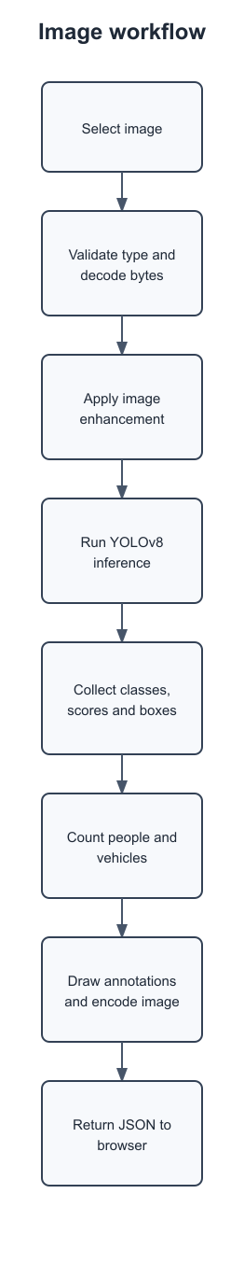
Figure 3.1: Image and Video Data Flow

3.4.2 Detection Result Flow
The result object's box collection supplies one entry for each retained prediction.
The route translates numeric class IDs into names through result.names and records coordinates and confidence.
Person detections increment person_count.
Since inference is restricted to one person class and four vehicle classes, remaining returned detections increment vehicle_count.

3.4.3 Image Request Sequence
The user selects an image; browser JavaScript creates FormData and posts it to the image endpoint.
FastAPI invokes the route, which calls the image decoder, enhancer, and detector in sequence. The route creates the response model and serializes it as JSON.
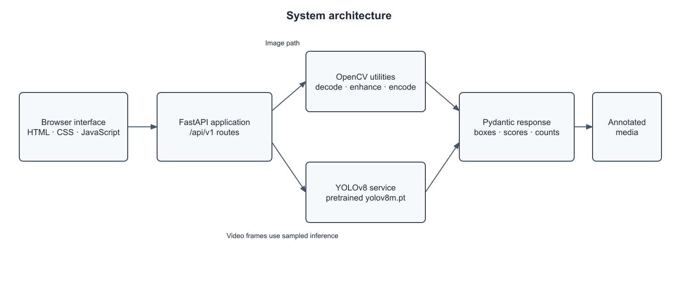
Figure 3.2: Image Request Sequence

3.4.4 Activity Diagram
The activity diagram follows validation, preprocessing, inference, annotation, and response handling.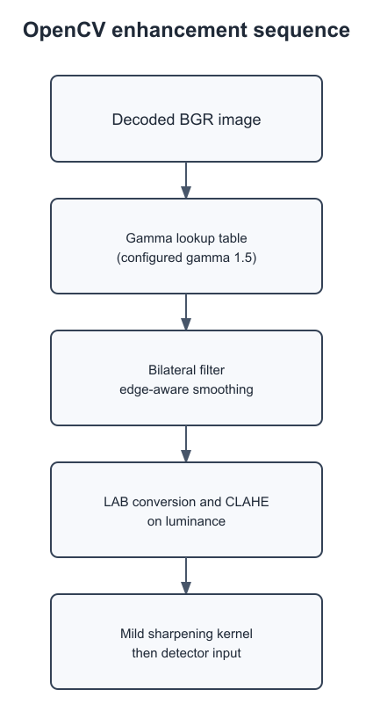
Figure 3.4: Activity Diagram

3.4.5 System Overview Diagram
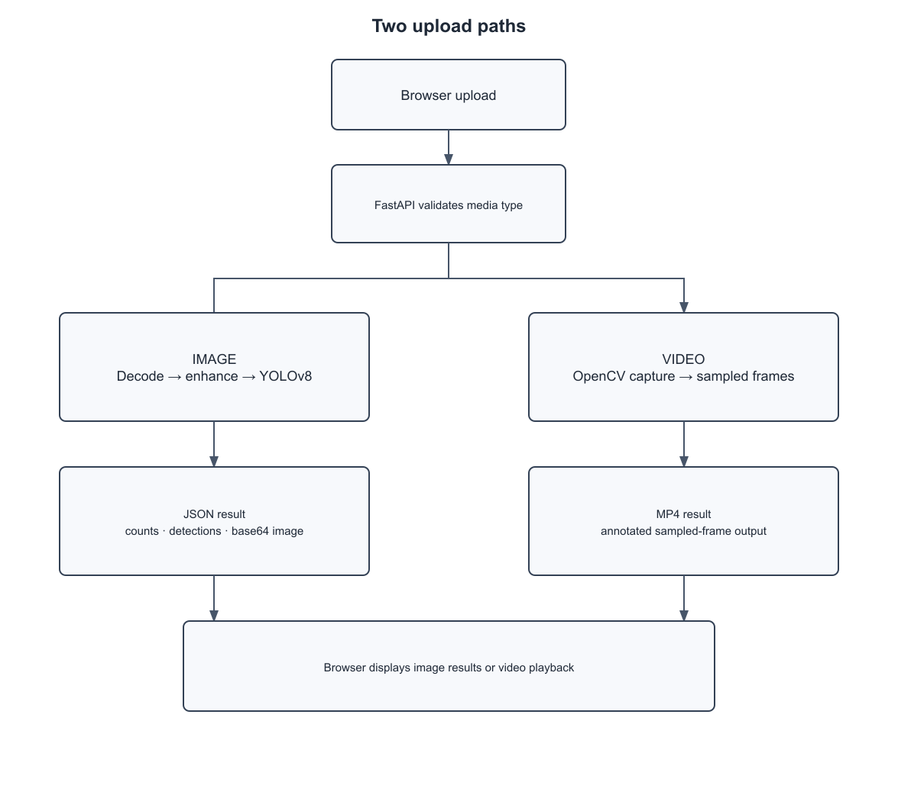
Figure 3.4: System Overview

3.4.6 System Architecture Diagram
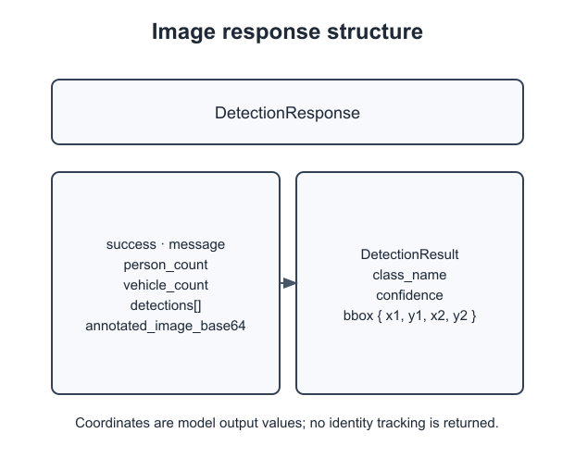
Figure 3.5: Application Architecture

3.4.7 Use Case Diagram
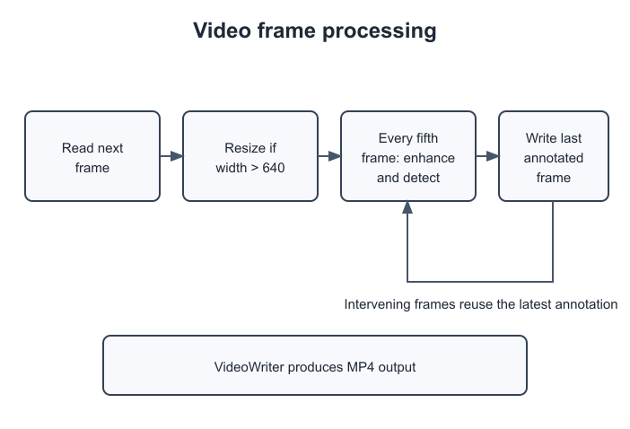
Figure 3.6: User Use Cases

Chapter 4

Implementation
This chapter explains the current implementation in terms of model inference, enhancement, API integration, browser behavior, and local operation. The source is a modular prototype rather than a model-training package. Descriptions of settings correspond to values visible in the configuration and service files. Recommendations for additional checks are identified as plans and are not reported as completed experiments.

4.1 Pretrained Detection Model
The application loads a supplied YOLOv8 medium checkpoint and invokes inference when an accepted image or sampled video frame is received. The model is a reusable third-party component. It is not trained as part of the request and its weights are not updated by the application.

4.1.1 Model Overview
ObjectDetector constructs YOLO(settings.MODEL_PATH) during module initialization and exposes a detect method. That method calls the model with the configured confidence threshold and allowed class IDs, then returns results[0].
The route uses the returned result for boxes, names, and plotting.
Loading once avoids reconstructing the model for every individual request.
It also means that model initialization is part of application startup and a missing weight file can prevent successful operation.
The class filter is passed to inference and limits the returned categories.
No project-specific classifier is layered on top of YOLO output.
The route treats the selected non-person classes as vehicles, which is valid under this fixed allow-list but would need revision if additional classes were enabled.

4.1.2 Weights and Class Selection
Configuration points to yolov8m.pt by a relative path.
The repository includes YOLOv8 n, s, and m weight files, but the active default is the medium checkpoint.
The class list is [0, 2, 3, 5, 7], corresponding to person, car, motorcycle, bus, and truck in COCO.
No training or validation dataset is included.
The proposal discussed public datasets, training, and standard metrics; those activities are not evidenced by the supplied application code and should not be represented as completed work.
The proposal mentions public data and evaluation, but the inspected application tree contains only model weight files and inference code.
Dataset selection, labels, licensing, training splits, and annotation policy remain unspecified.
They should be established before any fine-tuning or quantitative project claim.

4.1.3 Inference and Evaluation Plan
A request supplies an image array to the detector.
The service applies the confidence and class filters, and the API converts retained boxes to a response.
Evaluation should use a fixed labeled set not used to select settings.
Inference configuration:
Weights: yolov8m.pt
Confidence: 0.15
Class IDs: 0, 2, 3, 5, 7
Images should be grouped by source or scene before splitting to reduce near-duplicate leakage.
Evaluation measures:
Each class should have enough examples to estimate errors.
Predictions should be matched to ground-truth boxes using a stated intersection-over-union threshold, and precision, recall, and average precision should be reported per class.
A baseline should use the same weights and threshold on unenhanced inputs.
The repository contains no numeric results, so this section specifies a procedure rather than a measured outcome.
A held-out split should be separated by original video or capture session rather than random adjacent frames.

Confusion matrices were also generated to visualize true and false predictions for real and fake samples.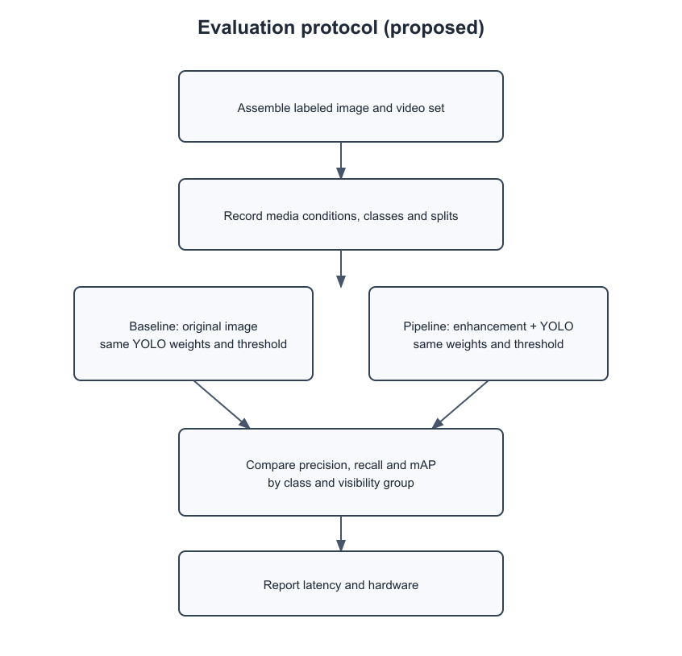
Figure 4.‎0.1 : test results

4.1.4 Confidence and Runtime Settings
The threshold is 0.15 and is passed directly to Ultralytics.
A low threshold can retain weaker predictions and may increase false positives.
The allowed class list limits returned categories but does not modify the model weights.
Video frames wider than 640 pixels are reduced proportionally; other frames keep their dimensions.
Video inference is sampled every five frames.
A zero frame-rate property is replaced with 30 frames per second for writing. These values are defaults in code, not results of a documented optimization search.

4.2 Image Preprocessing and Enhancement
Enhancement runs before detector inference for both routes. The pipeline operates on decoded BGR arrays and applies a fixed series of transformations.

4.2.1 OpenCV Enhancement Pipeline
First, the implementation creates an intensity lookup table with gamma 1.5 and uses cv2.LUT.
The enhancer applies:
The expression raises normalized input values to the reciprocal exponent; for mid-tone values this maps them upward, despite a code comment describing a darkening effect.
Second, bilateral filtering smooths local variation while aiming to preserve edges.
Third, the image is converted from BGR to LAB, CLAHE adjusts luminance, and the result returns to BGR.

4.2.2 Input and Output Image Handling
The upload route reads raw bytes.
Video width limit: 640 px
Image_utils converts them to a NumPy buffer and asks OpenCV to decode in color mode.
A decode failure returns a structured failure result.

4.3 FastAPI Integration and Model Serving
FastAPI provides endpoint registration, upload objects, static file service, redirects, and automatic API documentation. Detection and enhancement are imported as services. Request processing is executed in the application process. No asynchronous task queue or job scheduler is present.

4.3.1 Backend Implementation
The router defines POST /detect/image and POST /detect/video and is mounted under /api/v1.
The image route checks the declared content type, reads the upload, decodes it, processes the array, and constructs DetectionResponse, DetectionResult, and BoundingBox models.
It returns person and vehicle totals, a list of detections, and base64 annotation.
The video route writes the incoming file to temporary paths, opens the input, constructs a video writer, loops over frames, and returns FileResponse.

4.3.2 Frontend Implementation
Index.html defines the page title, upload zones, image counters, image preview, video player, and download link.
Style.css supplies a dark glass-style interface, tabs, upload areas, loading indicators, and responsive layout.
App.js switches tabs, wires drag-and-drop to file inputs, creates FormData, and sends fetch requests.
For image responses it populates the counts and base64 preview; for video it creates a browser object URL for playback and download.
Errors are surfaced with a simple alert and the upload zone is restored.

4.4 System Implementation
The repository's module structure makes it possible to trace one upload from browser event through route, service, and response.

4.4.1 Backend Development
Main.py creates the application and mounts static assets.
Config.py defines the API prefix, model filename, threshold, and class IDs.
Detection.py implements media routes. detector.py wraps the Ultralytics model.
Enhancer.py defines CLAHE and filter operations. image_utils.py handles image encoding and decoding.
Detection.py under schemas defines typed response objects.

4.4.2 Frontend Development
The page offers two tabs and separate file inputs whose accept attributes are image/* and video/*.
Interface features include:
Upload areas respond to clicks and drag-and-drop.
While a request is active, loading text is shown and previous results are hidden.
A successful image request updates two counters and an image element.
A successful video request creates a Blob URL and sets the player and download link.

4.4.3 Verification and Error Handling
Code paths can be reviewed for valid image type, invalid image type, decode failure, successful image inference, invalid video type, unreadable video, and unexpected video-processing exceptions.
The route has basic guards, but broader integration verification should check the response schema and file playback.
The existing test_client.py is not aligned to the implemented route and cannot be treated as an acceptance test without updating its path.

4.5 Local Deployment and Verification

4.5.1 Deployment Environment
The application is started from the project directory with uvicorn app.main:app --reload during development.
The local environment requires:
The root path redirects to the interface; /docs provides interactive API documentation.
The reload flag is suited to local development, not a production server.
Inference hardware is determined by the installed PyTorch/Ultralytics runtime and machine configuration.
The repository does not specify a container image, pinned dependency lock, GPU requirements, or production process manager.

4.5.2 System Verification Plan
Verify the root redirect, static page, interactive docs, both route paths, multipart field name, error responses, image response fields, and processed video format.
Exercise corrupt files and media with no target objects.

Chapter 5

User Interface and Features

This chapter describes the screens and actions available to a user of the current browser interface. The page is a static front end served by the FastAPI application. It offers separate image and video workflows and presents the results differently because the API returns JSON for images and a file for videos. The instructions below describe the supplied implementation and avoid implying features such as accounts, history, live streaming, or object tracking that are not present.
The user workflow begins in the browser and ends when the response is displayed or downloaded. The interface does not ask the user to choose a model or threshold, so the configured defaults determine the analysis.

5.1 Home Page Overview
When a user opens the application root, FastAPI redirects the browser to the static index page. The page heading is AI Object Detection and the summary describes detecting and counting persons and vehicles with enhancement.
Two buttons switch between Image Analysis and Video Analysis.
The visual layout places the content in a centered panel with a dark background, animated gradient, upload area, and loading and result states.
A user may choose a file through the upload prompt or drag and drop a file into the corresponding zone. The image and video tabs are separate views but share the same upload-zone pattern.
Each zone reacts to a click by opening its hidden file input and also accepts dropped files. The selected file is processed immediately; the page does not show a separate confirmation screen.
While the request is pending, the matching loading element is displayed and the old result is hidden. On completion, the response handler reveals the result panel.
This interaction keeps the number of steps small, but a user cannot cancel a long video request.
The page currently has no progress percentage, queue position, or estimated completion time.
A future version could add those states without changing the detector service, provided the backend also exposes job progress.
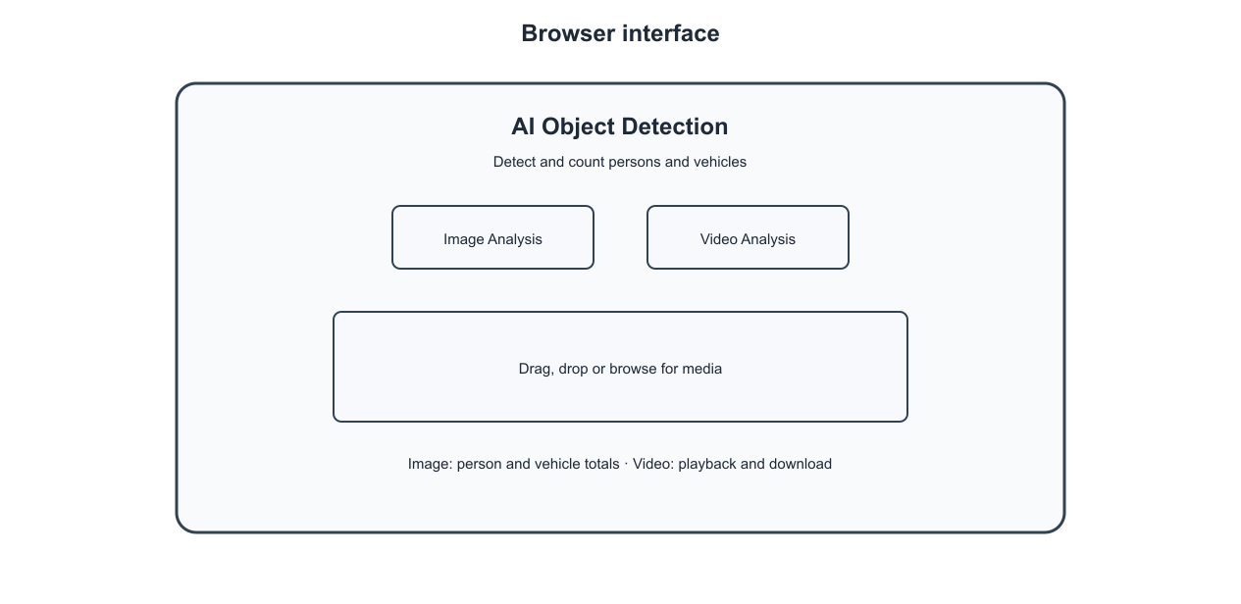
Figure 5.1: Browser Interface

5.2 Detection Result Interface
The image result view contains a person counter, a vehicle counter, and a preview element showing the annotated input.
These totals come from the image response. The route returns additional per-detection class names, scores, and coordinates, although the page does not display them in a detailed table.
The video result view contains an HTML video player and a download link for the processed MP4. The interface does not display a measured accuracy score or a confidence summary for the full video.
The browser displays only the two totals and the annotated image, although the API returns a richer list.
A future interface could show the class, score, and coordinates for each detection, with a way to inspect overlapping boxes.
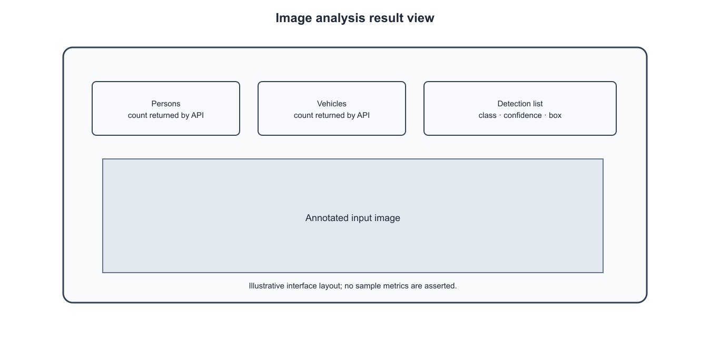
Figure 5.2: Image Result Interface

5.3 Navigation and Layout
Tabs are switched in JavaScript by toggling active classes on buttons and content panels. Each panel has a separate file input and upload zone. Once processing begins, the upload zone and prior result panel are hidden and a loading message is shown. At completion the loading element is hidden.
On a failed image response the page alerts the user and restores the upload area. A network error also triggers an alert and restores the upload.
The current code does not show upload progress, estimated wait time, or cancellation. The state changes are implemented in the browser rather than through full-page navigation.
Clicking a tab removes active classes from all tabs and panels, then activates the requested pair. The image and video upload handlers share a helper that controls loading and result visibility.
The helper posts FormData to a route supplied at initialization. Image responses are parsed as JSON; video responses are read as a Blob.
If the server returns a non-success HTTP status, the client raises an error and alerts the user.
This design handles the basic local workflow, but the current alerts are generic and do not expose a recovery explanation.

5.4 Interface Design Principles
The UI groups choices by media type, uses large clickable drop zones, and changes the visible state to indicate that a request is being processed.
The dark background and translucent card are implemented in CSS. Result images are displayed within a preview container.
The design is intended to make a local prototype approachable, but it should not obscure uncertainty about model predictions.
A box is a prediction and a count can be wrong.

5.5 Accessing the System
From the project directory, install the packages in requirements.txt into a compatible Python environment and ensure yolov8m.pt is available at the configured relative path. Start the development server with uvicorn app.main:app --reload. Open the local address printed by the server; the root route redirects to the UI.
The interactive API schema is at /docs. The reload option is for development.

5.6 Uploading Image and Video Files
In Image Analysis, choose or drop an image file. The browser sends the file as the multipart field file to POST /api/v1/detect/image.
The server checks the declared media type, decodes the image, enhances it, and runs the detector.
In Video Analysis, choose or drop a video file; the browser posts to /api/v1/detect/video.
The server saves the upload to a temporary file, reads frames, processes selected frames, and returns an MP4.
Processing time varies with input duration, dimensions, codec, hardware, and model speed.
The code does not specify an upload-size limit.
The server determines acceptance from the declared content type prefix and then attempts to decode or open the bytes.
The browser's accept attribute helps file selection but is not a security validation.
Users should select files that their installed OpenCV build can decode.
For video, output is generated as MP4 and may take substantially longer than image analysis because frames are read and written across the clip.

5.7 Interpreting Detection Results
Person and vehicle counters summarize returned image detections.
The class name specifies the model's predicted category, the confidence field is the model score, and bbox contains x1, y1, x2, y2 coordinates.
A score above the threshold is still not a calibrated probability or guarantee. Counts may include false positives and omit missed objects.
The annotated video reuses each sampled frame's boxes for intervening frames, so a rectangle may not stay aligned with a moving object. There are no track IDs, unique-person counts, or frame-by-frame structured results.
Result interface states:
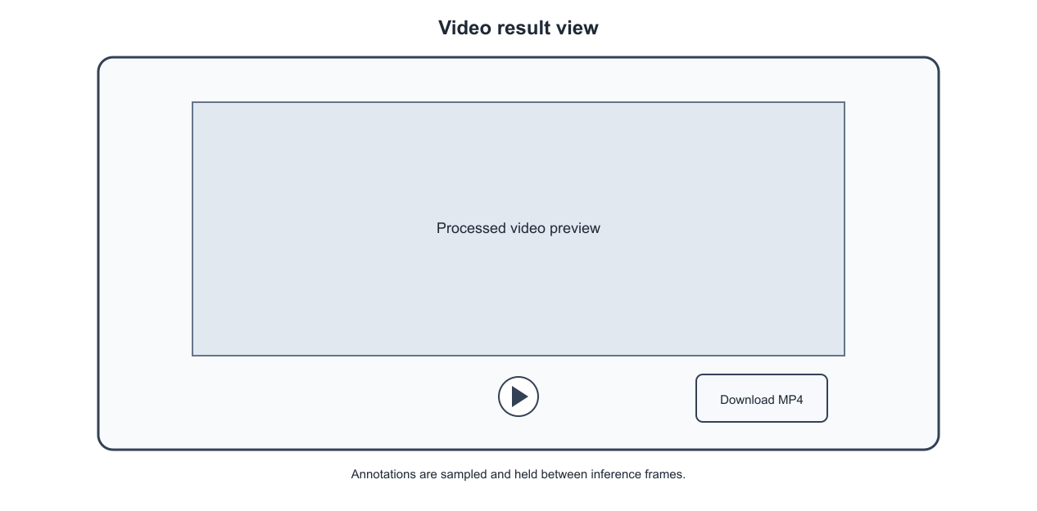
Figure 5.3: Video Result Interface

Chapter 6

Verification and Evaluation

This chapter states what can be established from the repository and defines how performance should be assessed. The project includes a functioning code path for uploading media, applying fixed enhancement, running a pretrained detector, and returning annotations. The supplied materials do not include a versioned labeled evaluation set, reproducible metric results, or timing measurements.

6.1 Verification and Evaluation Status
Source inspection confirms the route paths, content-type checks, image decoder, enhancement sequence, YOLO configuration, image response model, video resize threshold, frame sampling interval, and frontend result handling. The configuration sets confidence to 0.15 and uses class IDs 0, 2, 3, 5, and 7. These are implementation facts, not measurements of model quality.

6.1.1 Detection Performance Evaluation Plan
Build a labeled evaluation set containing images and video frames from clearly documented sources and conditions. Keep related frames or near-duplicate images in one split to avoid leakage.
Annotate visible instances of the five supported classes and record occlusion and visibility where possible.
Run the same weights on original inputs and enhanced inputs with a fixed threshold.
Match predictions to labels using a declared intersection-over-union criterion, then calculate precision, recall, average precision, and mean average precision per class.
Report sample counts, confidence threshold, image sizes, library versions, and hardware.
Screenshot:
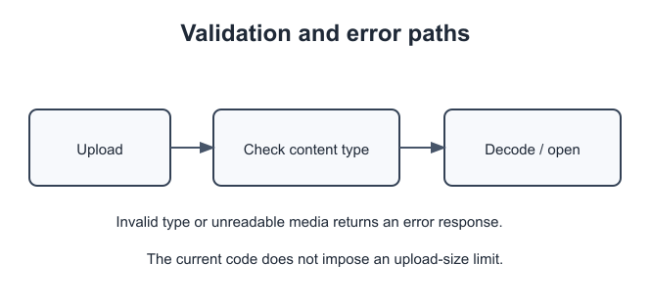
Figure 6.1: Validation and Error Paths

The repository supplies no completed metric table. Use the same class taxonomy when labeling and scoring data.
If a category is absent from an image, confirm that it is truly absent rather than merely difficult to see. Document annotation policy for partly visible vehicles, reflections, and truncated people.

6.1.2 Enhancement Evaluation
Compare three paths when data allows: unmodified input with YOLO, enhanced input with YOLO, and a manually inspected sample that identifies enhancement artifacts. Use identical weights and detector settings for the first two paths. Group results by low light, glare, fog, rain, blur, and clear conditions only when labels support those categories.

6.1.3 Confidence Threshold Evaluation
The configured value 0.15 controls which predictions are retained.
Evaluate a threshold sweep on validation data, choose a value according to a stated operating objective, and then report final results once on a held-out test split.

6.1.4 Processing Time Evaluation
Measure model startup separately from per-image and per-video request time. Record file dimensions, video duration, frame count, codec, CPU/GPU, package versions, and whether inference runs on CPU or GPU. For video, distinguish source frame rate from the actual inference frequency and the output-writing rate.

6.1.5 Web Application Verification
Exercise a valid image, an invalid declared type, unreadable image bytes, an image with no target objects, and examples containing each supported class. Confirm the response schema, count consistency, coordinate validity, and JPEG decoding.
For video, test supported and unsupported media types, unreadable files, short clips, wide frames, and clips whose reported frame rate is zero.

6.2 Evaluation Protocol
A reproducible study should freeze the checkpoint, package environment, class filter, enhancement values, and threshold before a test.

6.2.1 Representative Image and Video Sources
Include daylight and nighttime scenes, clear and adverse visibility, different object sizes and distances, multiple classes, crowded scenes, and occlusion when a source set supports these categories.
Record provenance and usage rights. Sample video frames consistently and prevent frames from the same clip appearing across training, validation, and test partitions if future training is performed.
Public datasets may be considered after checking license, class taxonomy, weather labels, and suitability for the project's intended scene. The current repository contains no such curated dataset.
When public datasets are considered, verify that their weather labels and class definitions match the experiment.
Record any filtering, frame sampling, or remapping.

6.3 Findings from the Implemented Prototype
The source demonstrates an integrated browser-to-API path, fixed image enhancement, pretrained inference, image counts and boxes, and video file generation.
Configuration and service boundaries are identifiable, which supports future parameter tests.
No evidence in the repository establishes detection accuracy, a gain from enhancement, robust operation under fog or rain, or real-time processing speed.
These outcomes should remain open questions until measured.

6.4 Limitations and Challenges

6.4.1 Technical Limitations
Enhancement parameters are fixed.
A video frame is resized only when wider than 640 pixels, and detection is run on every fifth frame; intermediate output frames reuse the most recent annotation.
The gamma expression does not implement the darkening described by its comment. The confidence threshold is not selected from a documented validation study.

6.4.2 Operational Limitations
Model memory and inference throughput depend on the machine and library build.
Video codecs may not be available in every environment.
There is no authentication or rate limit, so a shared deployment would need controls for who can submit media and how much compute they can consume.

6.5 Future Implications
The implementation can support a controlled research study and can be extended with evaluation datasets, more transparent thresholds, error analysis, or tracked video.
Each extension should be measured against a requirement.
A user interface can make model predictions easier to inspect, but does not itself make them reliable.
Responsible use depends on documented data handling, uncertainty communication, and appropriate human review.
If future results support a useful operating range, report where those results apply and how often the system fails.
Differences across conditions and object sizes should remain visible in the report rather than being hidden behind one aggregate score.

Chapter 7

Conclusions and Recommendations

This chapter summarizes the prototype and identifies work that would improve its evidence, reliability, and maintainability.

7.1 Conclusion
The project provides a modular application that accepts uploaded images and videos, applies fixed OpenCV enhancement, and runs pretrained YOLOv8 inference for selected people and vehicle classes. The image route returns counts, bounding boxes, confidence values, and an annotated image; the video route returns an MP4 with sampled-frame annotations. A browser interface provides file upload and result display.
The delivered code demonstrates integration of the components, but it does not include weather-specific training or a quantitative validation study. The project's objective is therefore met as a functioning prototype, while its accuracy and robustness remain to be evaluated.
The application should be described as an integration prototype because that is what the source demonstrates. Its current outputs make predictions inspectable, but they do not certify road safety, surveillance suitability, or performance on a specific weather domain. Those conclusions require additional data and testing.
An image result makes model output visible and supports inspection of counts and boxes. Video output provides a processed file, but sparse inference and frame reuse limit temporal interpretation. Before practical adoption, the application needs labeled evaluation, input safeguards, and documented operating conditions.

7.2 Contributions
The code organizes route handling, configuration, schemas, image utilities, enhancement, detection, and static presentation into separate modules.

It defines two media workflows and records concrete operating settings in configuration and route logic.
It also provides a direct way to inspect predictions through an annotated image and to receive processed video.
The documentation clarifies the distinction between pretrained inference and model training and gives a procedure for testing the claimed use case.
The modular files also provide a useful teaching example of how a pretrained vision model can be wrapped in an HTTP API and a static interface.
The integration makes the inference parameters and media-handling steps available for review.
The report records the route mismatch in the sample client so that future maintenance can correct it.

7.3 Lessons Learned
Integration is only one part of a computer-vision project.
A working detector call does not quantify correctness, and an enhancement filter's name or visual effect does not prove better detections.
The route and frontend must agree on endpoint names and response types; the supplied test client currently demonstrates the risk of an outdated route.
Video processing needs explicit choices about frame size, sampling, codec, and temporal consistency. Documentation is strongest when it identifies which properties come from code and which require measurement.
The evaluation plan should be designed before collecting results so that class definitions, splits, and thresholds are not adjusted after seeing test performance.

Stable input-output contracts also make it easier to compare model changes without rewriting the frontend. Claims should match available evidence, and every route should be tested with valid, malformed, empty, and unsupported media before local release.

7.4 Recommendations
Correct the stale client route, pin compatible dependencies, record the checkpoint checksum, and add functional checks for both media paths.
Validate file content beyond its declared MIME type, constrain upload bytes and video duration, handle exceptions consistently, and guarantee temporary-file cleanup. Select thresholds on validation data rather than by intuition.
Compare enhanced and unmodified inference on the same held-out samples. Preserve raw inputs and predictions only when justified by a documented retention policy.
For shared deployment, add authentication, concurrency limits, resource monitoring, and clear user guidance about uncertain predictions.
Add file-size, pixel-count, frame-count, and duration limits before accepting untrusted uploads. Verify the actual decoded media rather than relying only on a browser-provided MIME type.
Use temporary directories with deterministic cleanup and ensure the video writer is released on every exit path. Return structured errors that distinguish unsupported type, decode failure, and processing failure without leaking stack traces.
Add endpoint and schema checks to an automated verification suite.
For deployment, document memory and concurrency expectations because each application process may hold its own model. Record the threshold, allowed class IDs, weight checksum, and preprocessing settings alongside every reported metric.

7.5 Future Work
A first extension is a labeled dataset representing target scenes and visibility conditions, with documented source licenses and annotation rules.

A second is a controlled comparison of enhancement settings and detector thresholds using precision, recall, and mAP.
A third is a tracked video pipeline that associates detections between frames and reports when annotations were refreshed; tracking must not be confused with the current frame-reuse behavior.
Other practical work includes file-size validation, cleanup, job progress, cancellation, version-pinned packaging, and a production deployment guide.
Each change should be evaluated against documented requirements and reported with reproducible measurements.

References

[1] J. Redmon, S. Divvala, R. Girshick, and A. Farhadi, “You Only Look Once: Unified, Real-Time Object Detection,” Proceedings of the IEEE Conference on Computer Vision and Pattern Recognition, 2016. https://arxiv.org/abs/1506.02640
[2] T.-Y. Lin et al., “Microsoft COCO: Common Objects in Context,” European Conference on Computer Vision, 2014. https://arxiv.org/abs/1405.0312
[3] K. Zuiderveld, “Contrast Limited Adaptive Histogram Equalization,” in Graphics Gems IV, Academic Press, 1994, pp. 474–485.
[4] C. Tomasi and R. Manduchi, “Bilateral Filtering for Gray and Color Images,” Proceedings of the Sixth International Conference on Computer Vision, 1998, pp. 839–846.
[5] Ultralytics, “Predict Mode,” YOLO Documentation. https://docs.ultralytics.com/modes/predict (accessed September 2026).
[6] FastAPI, “Tutorial – User Guide,” https://fastapi.tiangolo.com/tutorial/; OpenCV, “OpenCV Documentation,” https://docs.opencv.org/ (accessed September 2026).

Abbreviations

AI Artificial Intelligence
API Application Programming Interface
CLAHE Contrast Limited Adaptive Histogram Equalization
COCO Common Objects in Context
CPU/GPU Central/Graphics Processing Unit
HTTP Hypertext Transfer Protocol
IoU Intersection over Union
JSON JavaScript Object Notation
MP4 MPEG-4 Part 14
YOLO You Only Look Once

